20. instrumentation and Monitoring Design
20.3 Geotechnical aspects
20.3.1 Settlement
Based on the geometry and relative compressibility, embankments may be subject to deformations parallel or transverse to the axis of the structure and may be in vertical and/or horizontal planes or in any intermediate direction. These deformations may be internal or on the surface of the embankment. Measuring horizontal, vertical, and transverse settlements both inside and on the embankment surface to understand how the embankment-foundation system is behaving is necessary. Unexpected movement or displacement is a very good indicator of distress conditions prior to jeopardizing the safety of the dam. The movement may be sub-divided into (a) foundation movement, (b) Surface settlement (Horizontal & Vertical). The following codes as presented in Table 21.1 will be adopted for the installation methodology and to determine the periodic maintenance schedule of the dam.
Table 21.1: IS codes for instrument installation and observation for settlement
Standard Number | Year | Description
IS: 7500 | 2000 | Code of practice for installation and observation of cross arms for measurement of internal vertical movement in earth dams
IS: 8266 | 1976 | Code of practice for installation and observation of base plates for measurement of foundation settlement in embankments

(a) Surface (Horizontal and vertical)
Measurement of relative displacement of two parts of the dam observed for the first few years reveals critical information about the adequacy of the structural performance of the dam, with respect to the design considerations. The relative movement of the parts of the dam, with other supporting data, may be used to study the elastic behavior of the dam, and to validate the design considerations. Any unexpected movement should be carefully investigated to preclude issues with the safety of the dam.
These observations can be made using permanent prism targets installed at 1 km spacing along the length of the dam. Additional prism targets may also be installed on the natural ground at the two ends of the dam. The positions of the prism targets can then be monitored using geodetic observations using a total station. It may also be possible to monitor the locations of these targets using GPS.
The detailed specification for the prism target to be adopted for the kalpasar dam is presented in Table 21.2.
Table 21.2: Specification chart for prism target
Name of Sensor | Prism target
Parameter Measured | settlement
Type of Sensor | NA
Location of Placement | Please refer to the attached sectional image (Fig. 1)
Number of Instruments | 4 nos. per transverse section with 1000m spacing in longitudinal direction
Range (Max. and Min.) | 0.3 to 600 mm
Resolution (Least Count) | ±1 mm
Frequency of collection | Monthly
Indian Standards | NA

(b) Foundation Settlement
Foundation displacement can either be vertical and/or horizontal Movement of the foundation is a very critical indicator of the structural performance of the dam. Any excessive or unexpected movement should be carefully investigated to preclude any impact on the safety of the dam. The monitoring data can also be used for studying the elastic and elastic properties of dam and foundation.
Ideally, the instruments should be located as close as possible to the founding level, generally, these are placed in the foundation gallery of the dam. The extensometers should be installed near the founding level at a spacing of 50 m, along each transverse section, which is spaced at 5 km along the length of the dam both in gulf area as well as tidal area.
Fill extensometers arranged both on the longitudinal and transverse section are recommended for the present project. The detailed specification for the fill extensometer that is to be adopted for the kalpasar dam is provided in Table 21.3.
Table 21.3: Specification chart for fill extensometer
Name of Sensor | Fill extensometer
Parameter Measured | Vertical and horizontal displacement
Type of Sensor | Vibrating wire
Location of Placement | Please refer to the attached sectional image (Fig.1)
Number of Instruments | 4 nos. per transverse section with 1000m spacing in the longitudinal direction
Range (Max. and Min.) | 50 -200 mm
Resolution (Least Count) | 0.125 mm
Frequency of collection | Every week during construction, every month for next three years, and every three months for 5 years post construction.
Indian Standards | NA

20.3.2 Pore Water Pressure and Uplift pressure
The effect of uplift on a dam is to reduce its effective weight due to the upward water pressure. The value of uplift pressure is indicative of operating reservoir head, effectiveness of grout curtain close to U/s face, and effectiveness of drainage curtain provided in foundation. It is important to determine the magnitude of uplift pressure at the base of the dam. Uplift pressure beneath the dam structures is generally varying linearly from headwater to tail-water or D/s ground surface – the presence of a grout curtain near the U/s face can change this linear variation. If foundation drains exist and are adequately maintained, the uplift pressure is usually reduced at the line of drains in accordance with the effectiveness of the drainage system.
The measurement of uplift pressure is of paramount importance for monitoring the structural behavior of a dam. It is required to determine the actual uplift pressures occurring below the barrage floor at different points especially just downstream of the gate seals and below the end of the pucca floor and to locate the zones where pressure is exceeding the safe balancing weight of the structure. It is also used to monitor piping phenomena if occurring anywhere below the floor area. It helps ensure that the hydraulic gradient of the subject-soil seepage flow is safe towards the end of the floor, so as not to exceed the safe exit gradient at the tail end of the dam and to compare the theoretically computed uplift pressures with those observed.
The device for measuring uplift consists of pipes, fitted with a T-section and a Bourdon type pressure gauge for observing water pressure, installed at the point where uplift pressure is to be measured, that is, typically at the foundation gallery, such that it terminates in a gallery directly above the measuring point which is generally 1 m below the base of a dam. Uplift pressure cells based on vibrating wire or unbonded resistance wire principle are available for remote monitoring.
Vibrating wire-type pressure sensors are to be adopted for the present project as they have high accuracy and high resolution. They can also be grouted into the structure with the help of a bentonite-cement grout. Hence the use of vibrating wire-type pressure meters is recommended for the present project. The detailed specification for the vibrating wire-type pressure meter to be adopted for the kalpasar dam is presented in Table 21.4.
Table 21.4: Specification chart for pressure sensor
Name of Sensor | Pressure sensor
Parameter Measured | Uplift pressure
Type of Sensor | Vibrating wire
Location of Placement | NA
Number of Instruments | NA
Range (Max. and Min.) | 0.2 to 0.5 MPa
Resolution (Least Count) | 0.05 to 0.125 Mpa
Frequency of collection | Daily
Indian Standards | NA

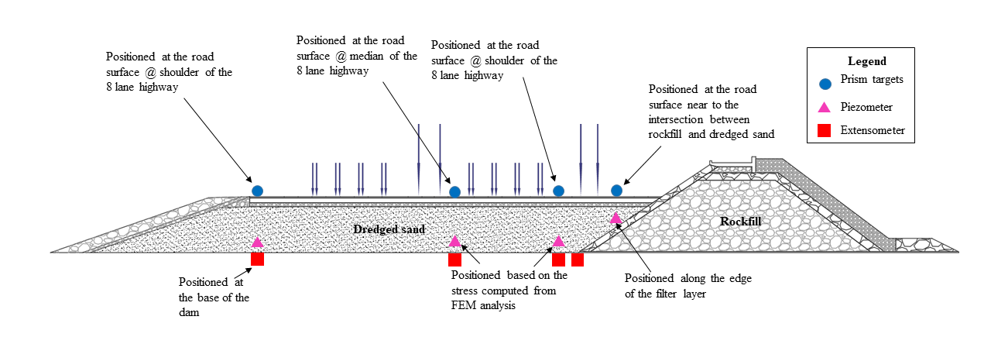Figure 21.1 Cross section representing the tentative location of instrument to be installed

20.10 Monitoring methods

20.10.1 Visual Monitoring
Visual inspections are useful for checking specific damage. The number of broken units per section of breakwater, and the type of break (important for structural analysis of armor units) can be checked visually but this is more time consuming than photographic methods, is not very quantitative in the degree of damage, and is not suitable for monitoring the entire slope.

20.10.2 Diver monitoring
Diver inspections are just an extension of visual inspections to below water, provided visibility is good. Recording can be done by video or still photography but position fixing is more difficult and the whole operation more time consuming.

20.10.3 Photographic monitoring using UAV
In this method, photographs of entire breakwater are taken at required time intervals and comparison of images gives an indication of movements or displacements in blocks. The images also help in finding the holes between the blocks to recommend filling extra material if necessary. Figure 21.2 shows the photographic monitoring from helicopter which was found to be best as it moves quickly between two stations. Differential GPS can be used to accurately (<1m) to fix the helicopter position.
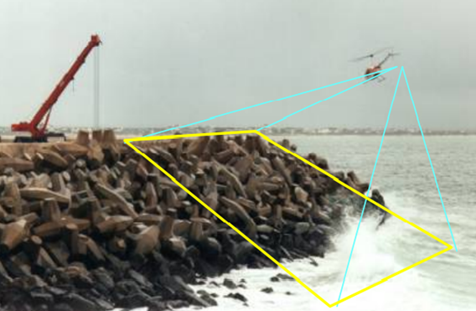
Figure 21.2 Photographic monitoring using helicopter (after: Kishan Tulsi et al. 2009)
Cumulative damage per station is the representative of block movements or deterioration and is calculated by comparing the present image with the previously recorded image. The relative damage is added to the previous cumulative damage. To ensure the accuracy, camera position and interior type need to be same for successive surveys. The damage parameter is categorized into three types. (A) < 0, 5 m, (B) 0, 5 m and (C) > 1,5 m, (D) breakage (E) loss or invisibility of block. Let N be the total number of blocks per station
$$Damage per station =\frac{C+D+E}{N}$$ | 6.1
The holes encountered in the armoring are filled, then the damage value reduces.
The critical damage criteria depend on the degree of protection from breakwater.

20.10.4 Crane and ball survey
- Moving crane is used to locate the ball over the break water profile for monitoring.
- Tacheometry or GPS is used to locate the level of the ball.
- The ball size must be constant for consecutive surveys.
- The level variation at each station for consecutive surveys give an understanding of units movements.
- This method is highly suitable for monitoring under water damage.
- For underwater damage case, the crane is fixed at each station along the breakwater profile with the boom perpendicular to it as shown in Figure 21.2.
- From the wall, the readings are taken at 3 m intervals in horizontal direction.
- At every location, ball is dropped down till it touches the armor unit and reading is recorded (Figure 21.3).
- Thus, the profile of armor units at each station can be recorded and can be compared with previous profile.
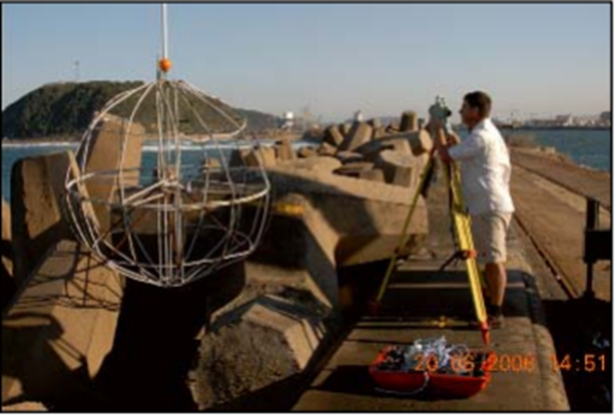
Figure 21.3 Crane and ball method of survey (after: Tulsi 2009)

20.10.5 Seismic, side scan sonar, and multi beam bathymetric survey
Seismic profiling will be used to check the profile of the original breakwater. The seismic profiling will also help in profiling the buried part of the breakwater which might have settled under the sand. The side profiling detail is very important for the breakwater repairs including the repair of toe berm. The sonar survey equipment can be operated either from a crane or boat depending on the sea conditions adjacent to the breakwater. The frequency of the survey will depend on the site condition and deterioration or dislocation frequency of the armour blocks in the breakwater.

20.10. 6 Tacheometric survey
Tacheometric survey may be used to accurately monitor positions and levels of the capping slab and specific armor units to identify general deterioration by settlement of the entire structure. Cracks in the capping slabs usually indicate settlement.

